**Task 1**

6 *×* 2 = 12 *marks*

**Name and Registration number:**  Apurba Koirala 22BCE3799



**The task files should have handwritten flow chart/Algorithm, and written Program, Snapshot of typed program and Snapshot of output.**

1. Write an assembly language program for multiplication of two 8-bit BCD numbers using the repeated addition logic. (NOTE: Without using MUL AB instruction)

Code and Flowchart:

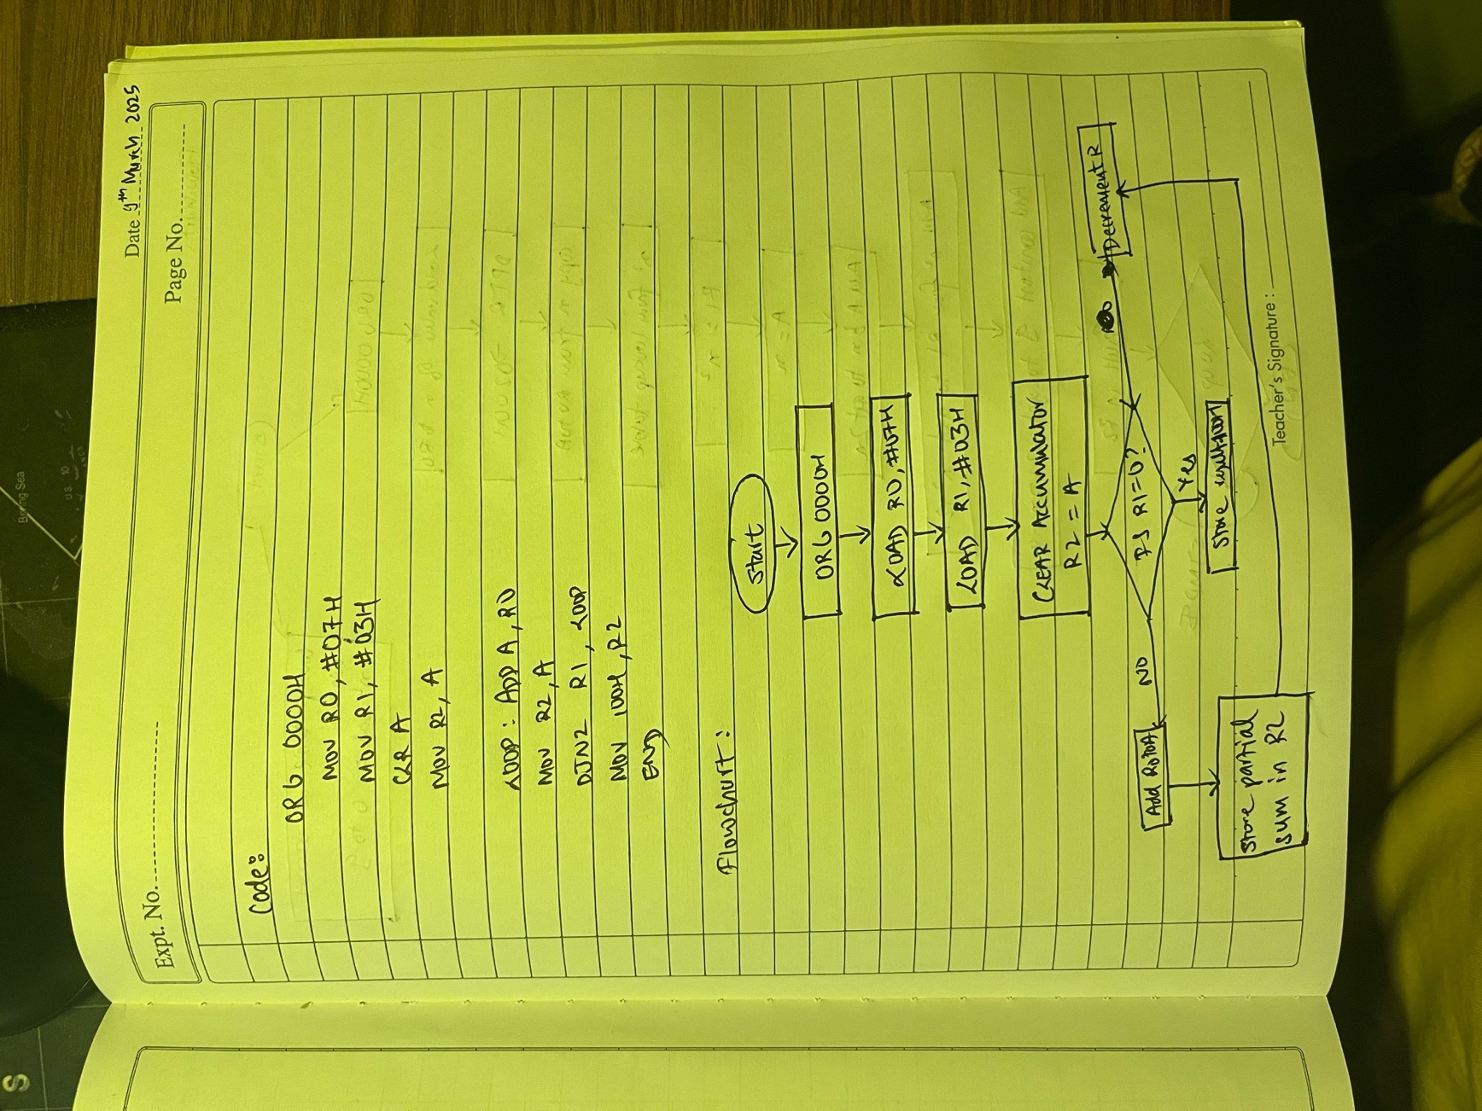

Snapshot of Code:

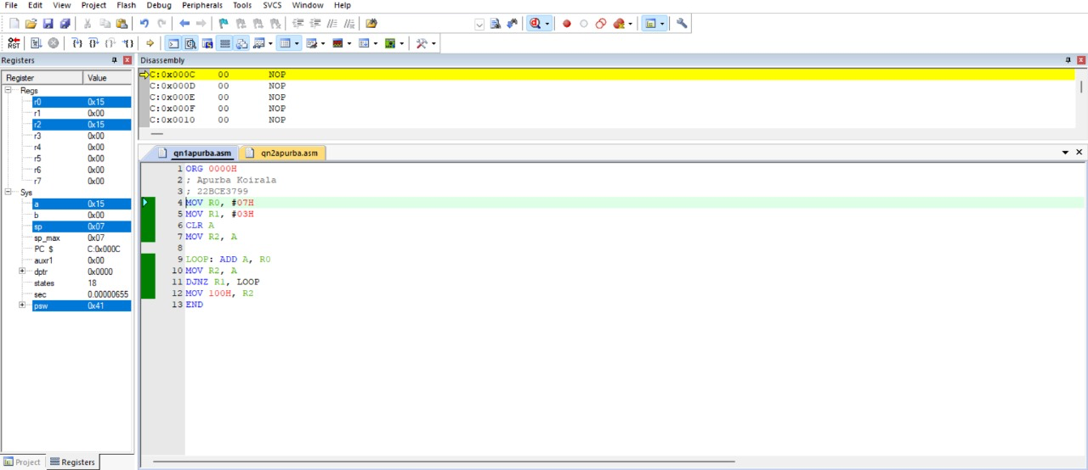

Output Snapshot:

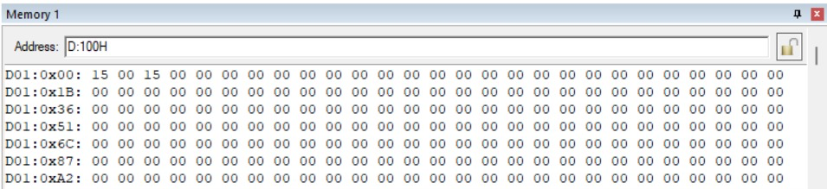

1. Write a program to calculate y where y = x2 + 2x + 9. x is between 0 and 9 and the lookup table for x2 is located at the address (code space) of 200H. Register R0 has the x, and at the end of the program R2 should have y. Use the simulator to change the x value and single-step through the program, examining the registers as you go.

Code and Flowchart:

Snapshot of Code:

Output Snapshot:

